Course Methods Year 12

Student name: ________________ Teacher name: ________________

Date: 14 Feb

Task type: Response

Time allowed for this task: _____45______ mins

Number of questions: _____8______

Materials required: Calculator with CAS capability (to be provided by the student)

Standard items: Pens (blue/black preferred), pencils (including coloured), sharpener, correction fluid/tape, eraser, ruler, highlighters

Special items: Drawing instruments, templates, notes on one unfolded sheet of
A4 paper, and up to three calculators approved for use in the WACE examinations

Marks available: __47____ marks

Task weighting: __10__%

Formula sheet provided: Yes

Note: All part questions worth more than 2 marks require working to obtain full marks.

Q1 (3.1.7) (9 marks)
Use the product rule and/or quotient rule to differentiate the following.(Simplify)
Note: Zero marks for answer only here.
- (3 marks)

- (3 marks)

- (3 marks)

Q2 (3 marks)
Determine the equation of the tangent to at the point .

Q3 (3.1.8) (8 marks)
Consider the functions and their derivatives with values given for the following x values.
X value | -1 | 3 | 7
 | 5 | 2 | -4
 | 0 | 1 | -2
 | 2 | 5 | -3
 | -1 | -2 | 6

Determine the derivatives of the following at the given x values.’

- at (2 marks)

- at (3 marks)

- at (3 marks)

Q4 (3.1.14, 3.1.15) (7 marks)
Use calculus techniques to determine the exact coordinates of any stationary points on the following curves and use the second derivative test to determine the nature of the stationary point.

- (3 marks)

- (4 marks)

Q5 (3.1.12) (7 marks)
The displacement of a body from an origin O, at time seconds, is metres
where , .

Determine the following.
- The velocity function. (2 marks)

- The times and displacements when the body is at rest. (3 marks)

- The distance travelled in the first 12 seconds. (2 marks)

- and explain its meaning. (2 marks)

Q6 (3.1.10) (3 marks)
If use the small increments formula to determine the approximate percentage change in when decreases by .

Q7 (3.1.11) (6 marks)
A colony of bacteria is represented as a circle on a petri dish and is increasing in such a way that the number of bacteria present is given by where , being the radius of the circle of bacteria.
- Determine and explain its meaning. (3 marks)

- Determine and explain its meaning. (3 marks)

Q8 (3.1.16) (4 marks)
Consider a closed hollow cylinder with end radius metres and length metres.
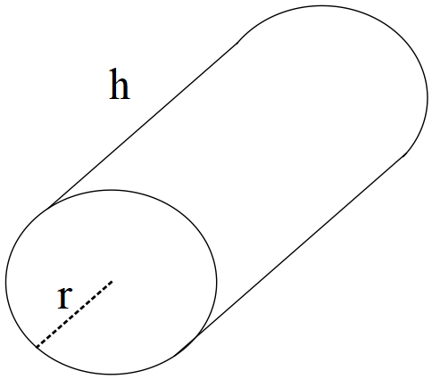

If the outside of the closed cylinder has a surface area of determine the dimensions of the radius and length, nearest cm, to maximise the capacity of the cylinder using calculus techniques.

Extra working space

Extra working space

